HAND GESTURE RECOGNITION

A project report submitted in partial fulfilment of the Academic requirements

for the award of the Degree of

BACHELOR OF ENGINEERING
IN

INFORMATION TECHNOLOGY

By

B. Mithilesh Reddy | (2451-16-737-031)
B. Siddharth Reddy | (2451-16-737-032)
Rahul Kulkarni | (2451-16-737-039)

Under the guidance of

K. Ramya Madhavi

Assistant Professor, Dept. of I.T

MVSR Engineering College

Nadergul, Hyderabad.

(Apr 2019)
/


DEPARTMENT OF INFORMATION TECHNOLOGY

MVSR ENGINEERING COLLEGE

(Affiliated to Osmania University, Hyderabad. Recognized by AICTE) Nadergul, Saroornagar Mandal, Hyderabad-501510 2018-2019
ACKNOWLEDGEMENT

We with extreme jubilance and deepest gratitude, would like to thank K.Ramya Madhavi , Assistant Professor, Department of Information Technology, MVSR Engineering College, for her constant encouragement and facilities provided to us to complete our project in time.

With immense pleasure, we record our deep sense of gratitude to our beloved Head of the department Dr.Ch.Samson, Department of Information Technology, MVSR Engineering College, for permitting us to carry out this project.

We would like to extend our gratitude to K.Srilaxmi, Assistant Professor, and D.Muninder, Assistant Professor, Department of Information Technology, M V S R Engineering College, for his valuable suggestions and timely help during the course of the project.

We express, from the bottom of our heart, my deepest gratitude to my parents and family for the support, dedication and love.

Finally, we express our heartfelt thanks to each and every one who directly and indirectly helped us in successful completion of this project work.

B.Mithilesh Reddy

(2451-16-737-031)

B.Siddharth Reddy

(2451-16-737-032)

Rahul Kulkarni

(2451-16-737-039)

ABSTRACT

The communication between the user and the computer can be done through various input devices such as the keyboard, mouse etc. However, this paper presents a more natural and intuitive form of communication i.e. via hand gestures. The gesture performed by the user is recognised and the action specific to it is performed, thus eliminating the use of any of the hardware input devices completely.
We use our hands constantly to interact with things: pick them up, move them, transform their shape, or activate them in some way. In the same unconscious way, we gesticulate in communicating fundamental ideas: ‘stop’, ‘come closer’, ‘over there’, ‘no’, ‘agreed’, and so on. Gestures are thus a natural and intuitive form of both interaction and communication. Gestures and gesture recognition are terms increasingly encountered in discussions of human-computer interaction. We present a tool created for human-computer interaction based on hand gestures. The underlying algorithm utilizes only computer-vision techniques. The tool is able to recognize in real time six different hand gestures, captured using a webcam. Experiments conducted to evaluate the system performance are reported.
This method makes use of image processing to recognise the gestures and has built in functions for every gesture provided by the PyAutoGUI module. It is coded in Python and uses the OpenCV library.

CONTENTS

Acknowledgement Page No.
Abstract
1. Introduction
1.1 Overview 1
1.2 What is Gesture Recognition? 1
1.3 What does the Project do 1
2. Literature Survey
2.1 Introduction 2
2.2 Existing System 2
2.3 Historical Review 3
2.4 Problems with Existing System 3
3. Analysis
3.1 Software Requirement Specification 4
3.1.1 User Requirement 4
3.1.2 Software Requirement 4
3.1.3 Hardware Requirement 4
3.2 Flowchart 5
4. Design and Implementation
4.1 Introduction 6
4.2 Input Part 6
4.2.1 CMake 6
4.2.2 Gesture Recognition 6
4.2.3 Haar Cascades 6
4.2.4 XML Classifier 6
4.2.5 Entries 6
4.3 System Overview 6
4.3.1 Module for Finding the Number of Convexity Defects 7
4.3.2 Module for finding the centre of the hand 8
4.3.3 Module for Identifying the Gesture 8
4.4 Algorithm for the System 9
4.5 Project Output 10
5. Testing and Validation
5.1 Introduction 14
5.2 Design of Test Cases and Scenarios 14 5.2.1 Detecting 14
5.3 Recognizing 14
5.4 Validation 14
5.5 Conclusion 14
6. Conclusion and Future Enhancements
6.1 Conclusion 15
6.2 Future Enhancements 15
References 16
Appendices
Code

CHAPTER 1
INTRODUCTION

1.1 Overview

Gesture is a form of nonverbal communication which involves movement of a part of the body, especially the hand usually to express an idea. In a human interaction, we make use of speech, gestures and body movements to convey information. The human-computer interaction which makes use of input devices such as keyboard or mouse for communication lacks natural communication between humans and machines. For this purpose, it is important to develop applications or devices that support intuitive communication.
As computer technology continues to grow, the need for natural communication between humans and machines also increases. Although our mobile devices make use of the touch screen technology, it is not cheap enough to be implemented in desktop systems.
Although the mouse is very useful for device control, it could be inconvenient to use for physically handicapped people and people who are not accustomed to use the mouse for interaction.

1.2 What is Gesture Recognition?

Gesture recognition is a type of perceptual computing user interface that allows computers to capture and interpret human gestures as commands. The general definition of gesture recognition is the ability of a computer to understand gestures and execute commands based on those gestures. Most consumers are familiar with the concept through Wii Fit, X-box and PlayStation games such as “Just Dance” and “Kinect Sports.”
Gesture recognition is an alternative user interface for providing real-time data to a computer. Instead of typing with keys or tapping on a touch screen, a motion sensor perceives and interprets movements as the primary source of data input. This is what happens between the time a gesture is made and the computer reacts.A camera feeds image data into a sensing device that is connected to a computer. The sensing device typically uses an infrared sensor or projector for the purpose of calculating depth. Specially designed software identifies meaningful gestures from a predetermined gesture library where each gesture is matched to a computer command. The software then correlates each registered real-time gesture, interprets the gesture and uses the library to identify meaningful gestures that match the library. Once the gesture has been interpreted, the computer executes the command correlated to that specific gesture.

1.3 What does this project do

In this project we recognize a hand gestures and it calculates the euclidean distance between the fingers. For complex gestures it calculates the angle using cosine rule and translates the gestures into meaningful sentence.

1

CHAPTER 2
LITERATURE SURVEY

2.1 Introduction

Gesture recognition is a topic in computer science and language technology with the goal of interpreting human gestures via mathematical algorithms. Gestures can originate from any bodily motion or state but commonly originate from the face or hand. Current focuses in the field include emotion recognition from face and hand gesture recognition. Users can use simple gestures to control or interact with devices without physically touching them. Many approaches have been made using cameras and computer vision algorithms to interpret sign language. However, the identification and recognition of posture, gait, proxemics, and human behaviours is also the subject of gesture recognition techniques.

2.2 Existing System

There are many systems in existence today that have implemented gesture recognition system of one or the other kind. Many of these systems have special requirements and working conditions and accuracy levels depending upon the technology used and the algorithms implemented to run the system. A brief comparison of the systems in existence and our proposed system can be seen as follows:

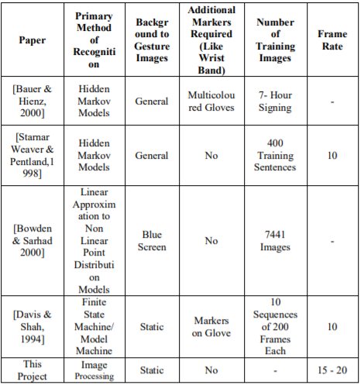

Table Comparison of Various Gesture Recognition Systems

2
2.3 Historical Review

The history of hand gesture recognition for computer control started with the invention of glove-based control interfaces. Researchers realized that gestures inspired by sign language can be used to offer simple commands for a computer interface. This gradually evolved with the development of much accurate accelerometers, infrared cameras and even fibreoptic bend-sensors (optical goniometers). Some of those developments in glove based systems eventually offered the ability to realize computer vision based recognition without any sensors attached to the glove. These are the coloured gloves or gloves that offer unique colours for finger tracking ability that would be discussed here on computer vision based gesture recognition. Over past 25 years, this evolution has resulted in many successful products that offer total wireless connection with least resistance to the wearer.

2.4 Problems with the Existing System

The existing system is based upon kinetic cameras which uses infrared rays to capture the outline of the hand. The accuracy with this model is high but an infrared camera is high in cost. The other existing system uses magic gloves which will record the hand movements accurately but this gloves consists of a lot of sensors which are high in cost.

3

CHAPTER 3
ANALYSIS

3.1 Software Requirement Specification

3.1.1 User Requirements

The user in this project is required to save the image of the person to be recognized and when the person is placed before the camera the software recognizes him. From the interface point of view, efforts have been made to keep the application as simple and user-friendly as possible.

3.1.2 Software Requirements

- Open CV Libraries
- Python 2.7
- Windows 7
- Supporting webcam drivers

3.1.3 Hardware Requirements

- Dual core or above processor
- Sufficient RAM to run the program.
- Webcam

4
3.2 Flowchart

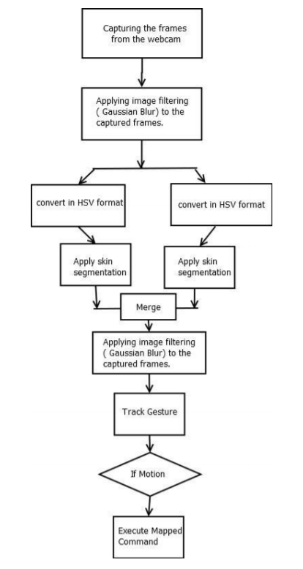

Process Flow Diagram for Hand Gesture Recognition System

5
CHAPTER 4
DESIGN AND IMPLEMENTATION

4.1. Introduction

Implementation of the code takes a number of modules to be in place and in suitable environments of different software. We had to complement each and every module to it’s respective version.

4.2. Input Part

Input part is prerequisite for hand gesture recognition system. Image acquisition operation is performed in this part. Live captured images are converted to digital data for performing image-processing computations. These captured images are sent to gesture detection algorithm.

4.2.1 CMake
CMake is used to control the software compilation process using simple platform and compiler independent configuration files, and generate native make files and workspaces that can be used in the compiler environment of your choice. The suite of CMake tools were created by Kitware in response to the need for a powerful, cross-platform build environment for open-source projects such as ITK and VTK.
4.2.2 Gesture Recognition

Recognize gestures from Python or from the command line with the help Convex Hull algorithm. Built using dlib’s state of the art gesture recognition built with deep learning. The model has an accuracy of 72.54%.

4.2.3 Haar Cascades

OpenCV comes with a trainer as well as detector. If you want to train your own classifier for any object like car, planes etc. you can use OpenCV to create one.

4.2.4 Entries

The entries can be a preloaded image or it can even be implemented with a live interface.

4.3 System Overview

The cursor movement by hand gestures is done using OpenCV library, uses Python programming language, which provides an ease to understand code through its simplicity. Python modules and packages used here are PyAutoGUI and NumPy. The captured video is broken down into continuous image frames using functions defined in OpenCV. The image frames are processed in order to detect any valid gestures being performed by the user. The basic architecture for the system is shown below.

6
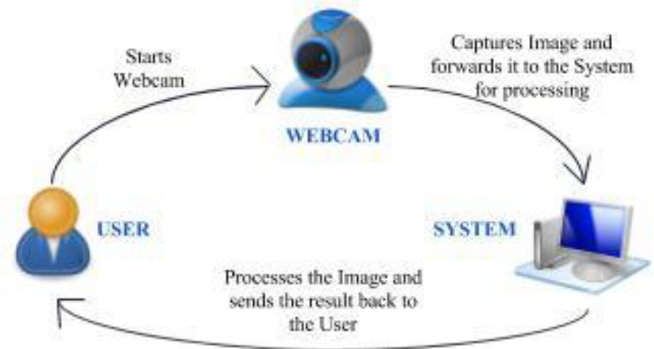

Figure 1. Basic architecture of the system

4.3.1. Module for Finding the Number of Convexity Defects

The convexity defects for the hand contour are first calculated by using the OpenCV inbuilt function “cvConvexityDefects()”. After the convexity defects are obtained, we perform steps for identifying the fingertips and the fingers.

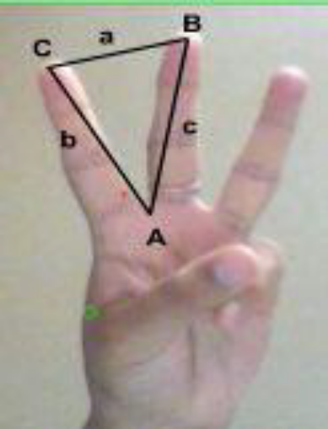

Figure 2. Finding convexity defect

Convexity defects obtained, is a structure that returns four values, start point, end point, farthest point and approximate distance to farthest point, out of which three have been used. The figure 2, denotes for one of the contours the start, the end and the far point. C represents the start point, B represents the end point and A is the farthest point. The angle made by the two fingers must be found to correctly determine if a finger is held up. This is done using the triangle formed by A, B and C. The length of each line is found using the distance formula as

a = √(start[0] − end[0]) 2 + (start[1] − end[1]) 2
b = √(start[0] − f ar[0]) 2 + (start[1] − f ar[1]) 2
c = √(end[0] − f ar[0]) 2 + (end[1] − f ar[1]) 2

7
Once the length of each have been found, using the Cosine rule, a 2 = b 2 + c 2 − 2bc cos A. The angle A is found using A = cos −1(b 2 + c 2 − a 2/2 * b * c). If the angle A is less than 70°, it is considered that two fingers are held up. The same technique is applied on all the defects to find the number of fingers held up. The approach can only be used to find the number of fingers, if the number of fingers held up are more than two.

4.3.2. Module for finding the centre of the hand

Before finding the gesture for one finger held up, the centre of the hand should be calculated. For this, first we considered a bounding rectangle that bounded the entire hand. From this we took an approximation of the palm of the hand. Every point in the palm of the hand was put to a pointPolygonTest of OpenCV, which returned the distance of the point to the nearest contour edge. A selection sort returned the point with the maximum distance. This point was considered to be the centre. The red circle in Figure 3 marks the centre of the hand.

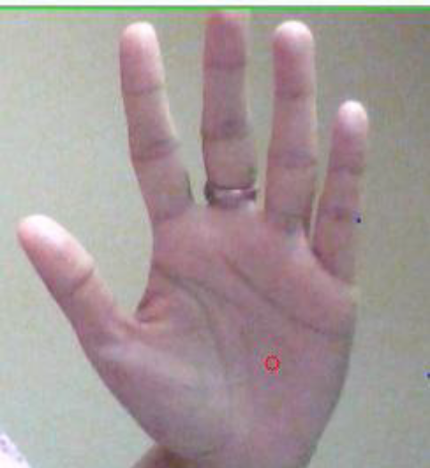

Figure 3. Finding the centre of the hand

4.3.3. Module for Identifying the Gesture

To find a single finger held up, here, we have taken the index finger, and a selection sort is performed to find the farthest distance from the center of the hand, given by (x,y). This farthest distance is compared against a range of distances that can be considered for the index finger. Another parameter for determining if the finger held up is the index, is the angle it makes with the center, given by (h,k). Assuming that every finger makes a different angle with the centre, we found the angle made by the finger using the formula,

A = tan −1((k − y)/(h − x))

If the angle and farthest distance lie within the range specified, we have concluded that the finger held up is the index finger. The Figure 4 shows the recognition of index finger by finding the distance from the centre of the hand (h,k), represented by the green circle, and the farthest point (x,y), in the hull.

8
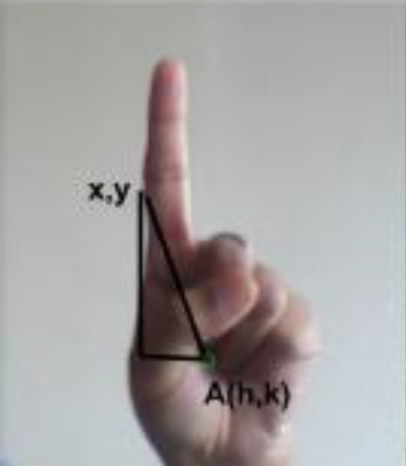

Figure 4. Identifying gesture

The next gesture we worked on needed to recognise two fingers held up in the way shown in Figure 5. The same technique of finding angle between two fingers was used here. The angle to which it was compared was however different from the one we specified for two consecutive fingers held up. In addition to this, the angle made by the pinky finger with the centre was also found and compared. The distance between the two fingers was found using the distance formula used above.

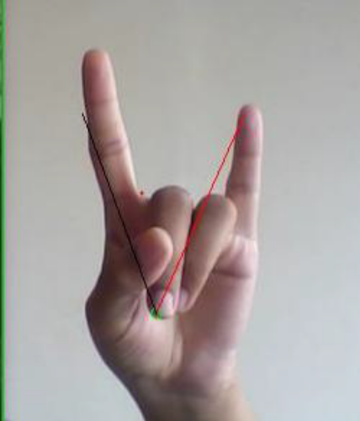

Figure 5. Identifying gesture

This way any gesture can be defined and recognised. We found our approach to be simple and easy to understand and manipulate.

9
4.4. Algorithm for the System

The following algorithm shows the basic steps performed by the system when gestures are detected.
START: Start the webcam
STEP 1: Detect the user’s hand
STEP 2: Capture the image
STEP 3: Identify the specific hand gesture
STEP 4: If the gesture for cursor movement is detected, go to STEP 10
STEP 5: If the gesture for single click is detected, go to STEP 11
STEP 6: If the gesture for double click is detected, go to STEP 12
STEP 7: If the gesture for drag is detected, go to STEP 13
STEP 8: If the gesture for left wave is detected, go to STEP 14
STEP 9: If the gesture for right wave is detected, go to STEP 15
STEP 10: Detect the coordinates of the mouse and perform cursor movement
STEP 11: Using coordinates from the mouse perform the selection, go to STEP 3
STEP 12: Perform selection or opening actions, go to STEP 3
STEP 13: Perform dragging action, go to STEP 3
STEP 14: Decrease the speed of the cursor
STEP 15: Increase the speed of the cursor
STEP 16: Stop

10
4.5 Project Output

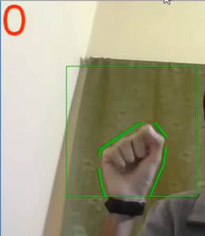

Figure 6. Gesture for 0

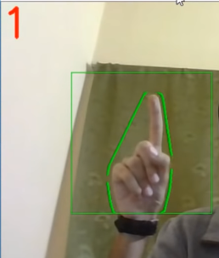

Figure 7. Gesture for 1

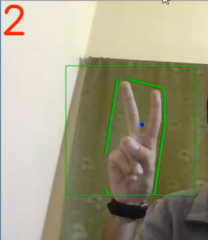

Figure 8. Gesture for 2

11

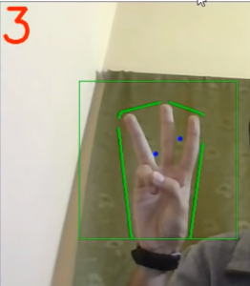

Figure 9. Gesture for 3

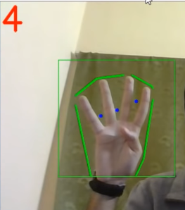

Figure 10. Gesture for 4

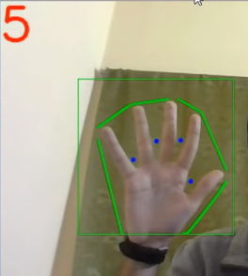

Figure 11. Gesture for 5

12

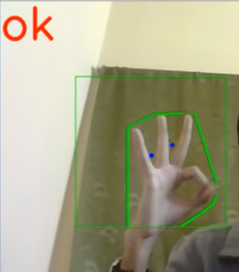

Figure 12. Gesture for OK

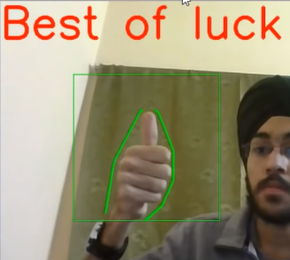

Figure 13. Gesture for Best of Luck

13
CHAPTER 5
TESTING AND VALIDATION

5.1. Introduction

Testing and validation of the program is a crucial part of project. It is impossible to determine all of the exceptional cases that might arise during the design of the program. Hence testing serves as a useful way to find the flaws in both the structure of the program and the implementation of the various functions.

5.2. Design of Test Cases and Scenarios

The test cases were designed keeping in mind where the program is liable to fail and throw errors or give erroneous outputs. The following cases are some of the important scenarios to be kept in mind.

5.2.1. Detecting

On detecting the hand will be fixed around a squared box, indicating it has recognized a face.

5.3. Recognizing

On recognizing the hand gesture meaning of the gesture appears.

5.4 Validation

This project has been tested on different inputs and testing for greater accuracy to detect hands better and to improve it’s functioning irrespective of different conditions.

5.5 Conclusion

After extensive testing and the final validation, it was concluded that the project is successful in carrying out all the functionalities mentioned throughout this report.

14

CHAPTER 6
CONCLUSION AND FUTURE ENHANCEMENT

6.1 Conclusion

This project describes a system that controls computer applications with the help of hand gestures. The method proposed here successfully created a hand gesture recognition system, that is able to recognise which gesture is performed by the user and accurately perform the functionality associated with it. Presently, the webcam, microphone and mouse are an integral part of the computer system. Our product which uses only webcam would completely eliminate the mouse. Also this would lead to a new era of Human Computer Interaction (HCI) where no physical contact with the device is required but it majorly helps to understand sign language.
We have presented a method for detecting hand gestures based on computer-vision techniques, together with an implementation that works in real time on a ordinary webcam. The method combines skin-color filtering, edge detection, convex-hull computation, and a rule based reasoning with the depths of the convexity defects. We had reported as well user experiments on the detection accuracy of the developed prototype, detecting correctly nine in ten hand gestures made on either hand, in a controlled environment.

6.2 Future Enhancement

The current system gives best results in a plain background and hence puts certain constraints on the user for successful working. The future work will include implementation of additional gestures which will enable the user to perform more functions with ease. Furthermore, background subtraction algorithm can be used for a more effective performance. The proposed system uses only one hand to perform gestures. Hence, enhancement of the technique proposed, is possible using both hands for performing different computer operations. Experiments need to be done on a larger scale so that results can be more accurate.

15

REFERENCES

1. Ann Abraham Babu, Satishkumar Varma, Rupali Nikhare, “Hand Gesture Recognition System for Human Computer Interaction Using Contour Analysis”, International Journal of Research in Engineering and Technology, eISSN: 2319-1163, pISSN: 2321-7308.

2. K. Madhuri, L. Praveen Kumar, “Cursor Movements Controlled By Real Time Hand Gestures”, International Journal of Science and Research (IJSR), India Online ISSN: 2319-7064.

3. Mark Bayazit, Alex Couture-Beil, and Greg Mori, ‘Real-time motion based gesture recognition using the gpu’, in IAPR Conference on Machine Vision Applications (MVA), (2009).

4. D. I. Ko and G. Agarwal, Gesture Recognition: Enabling Natural Interactions with Electronics. Dallas, TX, USA: Texas Instruments, Apr. 2012.

5. Swapnil D. Badgujar, Gourab Talukdar, Omkar Gondhalekar and S. Y. Kulkarni “Hand Gesture Recognition System”, International Journal of Scientific and Research Publications, Vol. 4, Issue 2, Feb. 2014, pp. 2250-3153.

16

APPENDICES

import cv2
import numpy as np
import math
cap = cv2.VideoCapture(0)
while(1):
try: #an error comes if it does not find anything in window as it cannot find contour of max area
#therefore this try error statement
ret, frame = cap.read()
frame=cv2.flip(frame,1)
kernel = np.ones((3,3),np.uint8)
#define region of interest
roi=frame[100:300, 100:300]
cv2.rectangle(frame,(100,100),(300,300),(0,255,0),0)
hsv = cv2.cvtColor(roi, cv2.COLOR_BGR2HSV)
# define range of skin color in HSV
lower_skin = np.array([0,20,70], dtype=np.uint8)
upper_skin = np.array([20,255,255], dtype=np.uint8)
#extract skin colur imagw
mask = cv2.inRange(hsv, lower_skin, upper_skin)
#extrapolate the hand to fill dark spots within
mask = cv2.dilate(mask,kernel,iterations = 4)
#blur the image
mask = cv2.GaussianBlur(mask,(5,5),100)
#find contours
_,contours,hierarchy= cv2.findContours(mask,cv2.RETR_TREE,cv2.CHAIN_APPROX_SIMPLE)
#find contour of max area(hand)
cnt = max(contours, key = lambda x: cv2.contourArea(x))
#approx the contour a little
epsilon = 0.0005*cv2.arcLength(cnt,True)
approx= cv2.approxPolyDP(cnt,epsilon,True)
#make convex hull around hand
hull = cv2.convexHull(cnt)
#define area of hull and area of hand
areahull = cv2.contourArea(hull)
areacnt = cv2.contourArea(cnt)
#find the percentage of area not covered by hand in convex hull
arearatio=((areahull-areacnt)/areacnt)*100
#find the defects in convex hull with respect to hand
hull = cv2.convexHull(approx, returnPoints=False)
defects = cv2.convexityDefects(approx, hull)
# l = no. of defects
l=0
#code for finding no. of defects due to fingers
for i in range(defects.shape[0]):
s,e,f,d = defects[i,0]
start = tuple(approx[s][0])
end = tuple(approx[e][0])
far = tuple(approx[f][0])
pt= (100,180)
# find length of all sides of triangle
a = math.sqrt((end[0] - start[0])**2 + (end[1] - start[1])**2)
b = math.sqrt((far[0] - start[0])**2 + (far[1] - start[1])**2)
c = math.sqrt((end[0] - far[0])**2 + (end[1] - far[1])**2)
s = (a+b+c)/2
ar = math.sqrt(s*(s-a)*(s-b)*(s-c))
#distance between point and convex hull
d=(2*ar)/a
# apply cosine rule here
angle = math.acos((b**2 + c**2 - a**2)/(2*b*c)) * 57
# ignore angles > 90 and ignore points very close to convex hull(they generally come due to noise)
if angle <= 90 and d>30:
l += 1
cv2.circle(roi, far, 3, [255,0,0], -1)
#draw lines around hand
cv2.line(roi,start, end, [0,255,0], 2)
l+=1
#print corresponding gestures which are in their ranges
font = cv2.FONT_HERSHEY_SIMPLEX
if l==1:
if areacnt<2000:
cv2.putText(frame,'Put hand in the box',(0,50), font, 2, (0,0,255), 3, cv2.LINE_AA)
else:
if arearatio<12:
cv2.putText(frame,'0',(0,50), font, 2, (0,0,255), 3, cv2.LINE_AA)
elif arearatio<17.5:
cv2.putText(frame,'Best of luck',(0,50), font, 2, (0,0,255), 3, cv2.LINE_AA)
else:
cv2.putText(frame,'1',(0,50), font, 2, (0,0,255), 3, cv2.LINE_AA)
elif l==2:
cv2.putText(frame,'2',(0,50), font, 2, (0,0,255), 3, cv2.LINE_AA)
elif l==3:
if arearatio<27:
cv2.putText(frame,'3',(0,50), font, 2, (0,0,255), 3, cv2.LINE_AA)
else:
cv2.putText(frame,'ok',(0,50), font, 2, (0,0,255), 3, cv2.LINE_AA)
elif l==4:
cv2.putText(frame,'4',(0,50), font, 2, (0,0,255), 3, cv2.LINE_AA)
elif l==5:
cv2.putText(frame,'5',(0,50), font, 2, (0,0,255), 3, cv2.LINE_AA)
elif l==6:
cv2.putText(frame,'reposition',(0,50), font, 2, (0,0,255), 3, cv2.LINE_AA)
else :
cv2.putText(frame,'reposition',(10,50), font, 2, (0,0,255), 3, cv2.LINE_AA)
#show the windows
cv2.imshow('mask',mask)
cv2.imshow('frame',frame)
except:
pass
k = cv2.waitKey(5) & 0xFF
if k == 27:
break
cv2.destroyAllWindows()
cap.release()

